MIC 2024 Schedule of Events
The University of Chicago
David Rubenstein Forum
1201 E. 60th St, Chicago, IL 60637
https://drtc.bsd.uchicago.edu/mic-2024

Wednesday, July 10, 2024

11:30 am – 1:00 pm Registration/Poster Set-Up/Lunch

1:00 pm Welcome and Introduction
Raghu Mirmira University of Chicago

1:15 pm – 1:45 pm Young Investigator Award Presentation/Talk
Danielle Dean Vanderbilt University

1:45 pm – 2:45 pm Session I. The Blueprints of β-Cell Maturity and Function
Moderator: Michael Kalwat

1:45 pm #28 Katy Matson Michigan Technological University
miR-483 deficiency induces β-cell dedifferentiation to α-cells

2:00 pm #72 Kelly Vazquez Wheaton College
Modulation of the biomechanical environment alters β-cell function and maturity

2:15 pm #45 Madison Thomas University of Pittsburgh
The acute knock out of glucagon in α-cells leads to impaired glucose homeostasis and β-cell dysfunction

2:30 pm #10 Jennifer Stancill Medical University of South Carolina
Thioredoxin reductase 1 is required for normal pancreatic β-cell function

2:45 pm – 3:00 pm Break

3:00 pm – 4:15 pm Session II. Conductors of the Insulin Secretion Symphony
Moderator: Katie Coate

3:00 pm #63 Nathaniel York Washington University in St. Louis
Chronic KATP inhibition or depolarization results in decreased Ca2+-sensitivity of insulin secretion

3:15 pm #47 Ben Thompson University of Michigan
Regulation of islet pulsatility by pyruvate dehydrogenase

3:30 pm #70 Ava Stendahl University of Michigan
Loss of the mitochondrial inorganic phosphate transporter impairs β-cell glucose-stimulated insulin secretion despite a maintenance of ATP levels

3:45 pm #78 Jade Stanley Vanderbilt University
SLC7A2-dependent arginine transport in α-cells signals arginine tone to regulate insulin secretion

4:00 pm #7 Shannon Townsend Washington University in St. Louis
Serotonin signals through the cilia-localized serotonin receptor 6 to stimulate β-cell autocrine insulin secretion

4:15 pm – 4:30 pm Break

4:30 pm – 6:00 pm Session III. Metabolic Matrix: Stress, Obesity, and Islet Health
Moderator: Jing Hughes

4:30 pm #86 Brian List Ohio University
Reducing glycolysis uniquely maintains normal islet function in chronic hyperglycemic conditions

4:45 pm #19 Luhui Zhang Mayo Clinic
Effects of diet-induced obesity on circadian regulation of β-cell function and islet circadian transcriptome in male and female mice

5:00 pm #74 Rashaun Williams Washington University in St. Louis
Impact of in vivo microenvironment on viability and function of transplanted islets

5:15 pm #42 Catharina Villaca Indiana University
Impaired on-demand protein synthesis drives β-cell dysfunction

5:30 pm #4 Molly Mulcahy University of Wisconsin-Madison
Cholecystokinin expression in islets under metabolic stress

5:45 pm #87 Christopher Acree Vanderbilt University
High-resolution mapping of glucose-derived 13C in pancreatic islets using MIMS-EM: Unraveling organelle interactions and metabolic flux

6:00 pm – 7:00 pm Cocktail Hour

7:00 pm – 9:00 pm Dinner and Posters

Thursday, July 11, 2024

8:00 am – 9:00 am Breakfast

9:15 am – 10:30 am Session IV. Cellular Crossroads: ER Stress and Inflammation
Moderator: John Corbett

9:15 am #38 Jacob Bartosiak Medical College of Wisconsin
IL-1β inhibits encephalomyocarditis virus (EMCV) replication in pancreatic islets

9:30 am #20 Erica Cai Indiana Biosciences Research Institute
Genome-scale in vitro CRISPR screens identify an ER export cargo protein as a mediator for β-cell stress response and autoimmune vulnerability

9:45 am #80 Renato Branco Indiana University
Knockout of ryanodine receptor 2 partially prevents tunicamycin-induced misfolded protein accumulation and β-cell death

10:00 am #6 Caterra Leavens University of Wisconsin-Madison
The β-cell “invisibility cloak” – Developing stem cell derived pancreatic β-cells that are protected from the immune system

10:15 am #69 Paul Sidlowski Medical College of Wisconsin
Bromodomain and extraterminal domain proteins in inflammatory activation of pancreatic islet resident macrophages

10:30 am – 10:45 am Break

10:45 am – 12:00 pm Session V. Rewriting Diabetes: Innovations in T1D Research
Moderator: Sarah Tersey

10:45 am #61 Justin Choe Mayo Clinic
ST8Sia6 overexpression protects pancreatic β-cells from spontaneous autoimmune diabetes in NOD mice

11:00 am #39 Titli Nargis University of Chicago
Inhibition of 12-lipoxygenase modifies autoimmune diabetes pathogenesis and delays progression to hyperglycemia in human gene replacement mice

11:15 am #35 Matthew Austin Indiana University
Characterizing the role of autophagy in type 1 diabetes development

11:30 am #8 Alexander Hopkirk Vanderbilt University
Altered islet morphology and increased extracellular matrix deposition in type 1 diabetes

11:45 am #23 Charanya Muralidharan University of Chicago
Inhibition of the PERK (eukaryotic initiation factor 2α kinase) decreases risk of autoimmune diabetes in mice

12:00 pm – 1:00 pm Lunch

1:15 pm – 1:45 pm Awards and Lacy Medal Presentation

1:15 pm Midwest Islet Club Presentation and Poster Awards

1:30 pm Lacy Medal Lecture Introduction and Award

1:45 pm 2024 Lacy Medal Lecture
Rohit Kulkarni Harvard Medical School, Joslin Diabetes Center

2:45 pm Closing Remarks
MIC Organizers

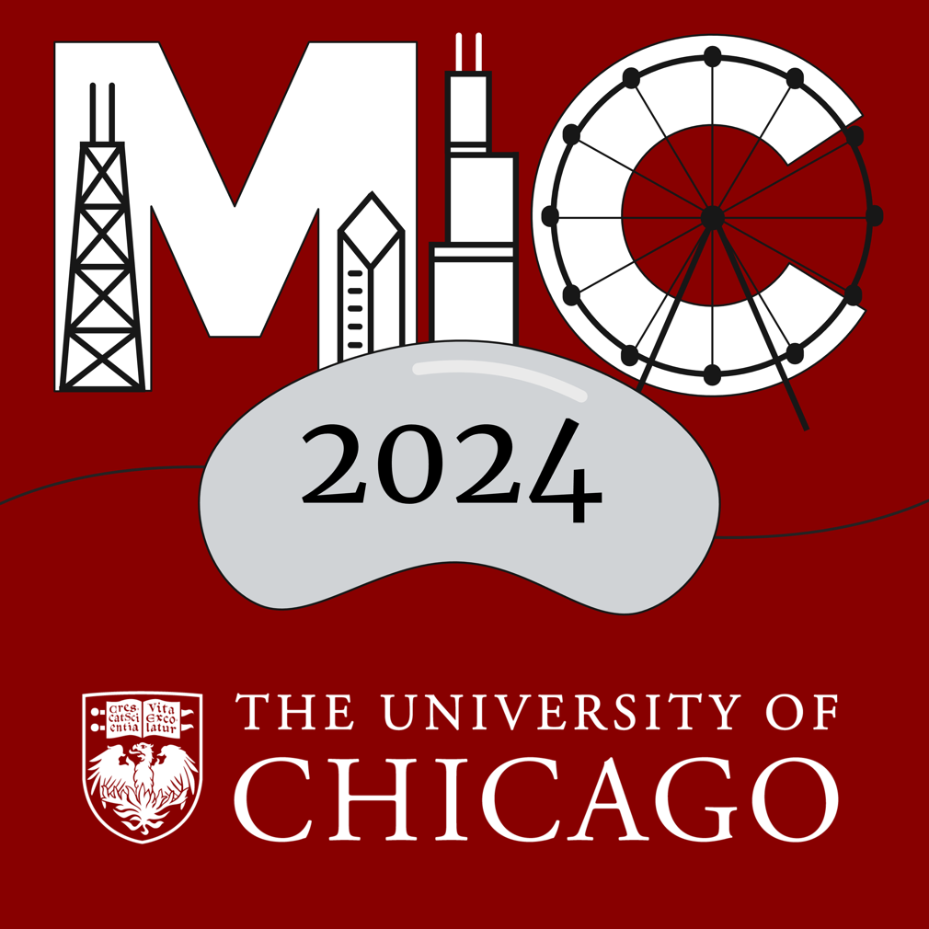
3:00 pm Meeting Adjourned

